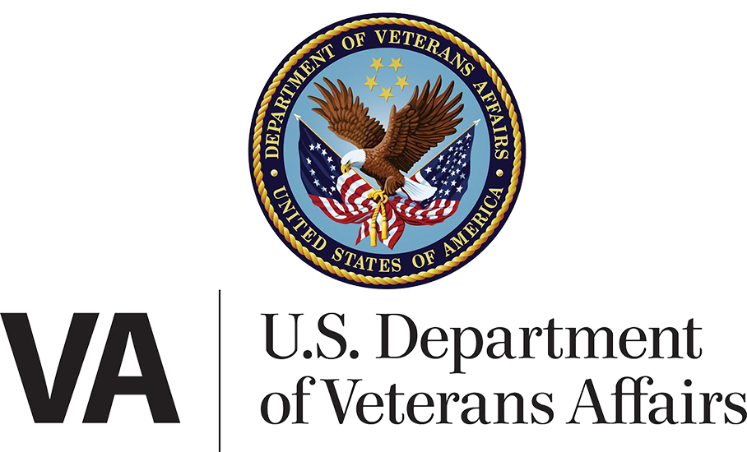

Department/CTO Health Team

March 13, 2025| My HealtheVet on VA.gov Portal and Landing Page Product Guide

Version 4.0

Revision History

| **Date** | **Version** | **Description** | **Author** |
| --- | --- | --- | --- |
| 03/21/2023 | 1 | Landing Page debut | Marci McGuire |
| 06/04/2024 | 2.0 | Integration of tools on VA.gov w/MHV navigation | Wes Rowe |
| 12/11/2024 | 3.0 | Integration of MHV Account Creation API, new Medical Records tool on VA.gov | Wes Rowe |
| 3/13/2025 | 4.0 | Updating revised “no access to My HealtheVet” alert | Jonathan Nelson |

Table of Contents

1. Product Overview 4

New: Integration of tools into VA.gov 5

Navigation element across the My HealtheVet-on-VA.gov portal 6

2. User Access 6

Alert case: sign-in credential needs identity verification 7

Alert case: no access to My HealtheVet 7

If a user sees this yellow alert but believes it to be erroneous: 8

Alert case: MHV User Account problem / API error (new, Dec 2024) 8

MHV Account Error displayed to user – Landing Page 8

MHV Error codes 9

3. Navigation and primary functionality 10

How users can reach the My HealtheVet Portal and Landing Page 10

Starting from VA.gov 10

My HealtheVet secondary navigation 11

Getting back to the previous version of My HealtheVet 12

Links within landing page 12

4. Common issues and error messages 12

## 1. Product Overview

The My HealtheVet-on-VA.gov landing page serves as a front door to VA.gov’s health-related applications. At the launch of the landing page in March of 2023, many of the health tools it linked to were still located on the My HealtheVet National portal website (secure messaging, medications, and medical records). Only the Appointments tool was located on VA.gov at that time.

In Veteran-facing content within the My HealtheVet-on-VA.gov portal, **the My HealtheVet National Portal website is referred to as** “**the previous version of My HealtheVet.”** (Its URL is [myhealth.va.gov](http://myhealth.va.gov).)

Figure 1. Screenshot of My HealtheVet-on-VA.gov Landing Page when Medical Records goes live on VA.gov, mid-Dec 2024.

### New: Integration of tools into VA.gov

In early June 2024, the My HealtheVet-on-VA.gov portal became a more self-contained, health portal-like experience. Mid-December 2024, when Medical Records goes live on VA.gov, all four main health tools will be available on VA.gov:

* Appointments
* Secure messaging
* Medications
* Medical Records

**Note the** “**NEW” tag at the top of the Landing Page.** This has been added to the H1 header of the Landing Page and also to the top-level pages of the Secure Messaging, Medications, and Medical Records tools. (It has not been added to the Appointments tool, which has been live on VA.gov for a few years.) When you receive calls with inquiries about My HealtheVet tools, this may be a useful indicator to confirm that the caller is on the new VA.gov version of a tool.

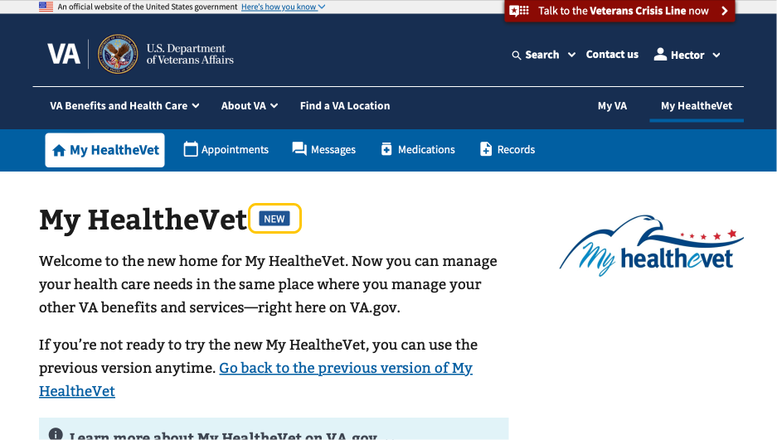

Figure 2. "NEW" tag on main header

#### Navigation element across the My HealtheVet-on-VA.gov portal

The new My HealtheVet navigation bar is present on every page within the My HealtheVet-on-VA.gov portal, on both desktop and mobile devices. The navigation bar links to four tools - Appointments, Messages, Medications, and Medical records - as well as to the My HealtheVet landing page.

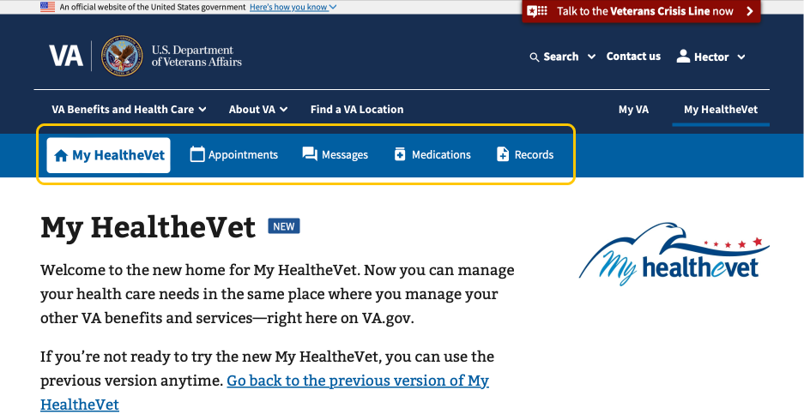

Figure 3. New MHV navigation element (desktop)

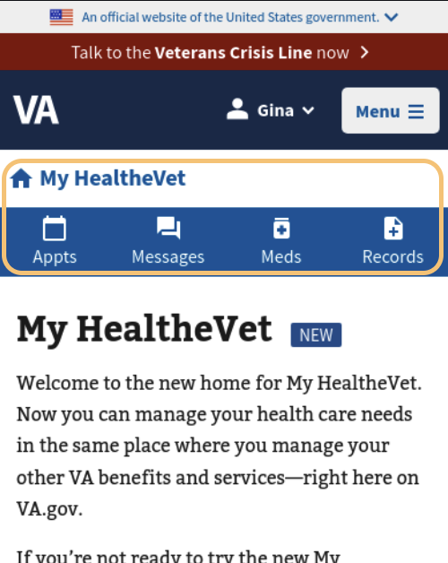

Figure 4. New MHV navigation element (mobile)

## 2. User Access

For a user to view the complete My HealtheVet-on-VA.gov Landing Page (including links to health tools as described in this document), they must meet the following criteria:

1. Signed into VA.gov with an identity-verified credential issued by either **Login.gov** or **ID.me**. (The MHV sign-in credential is omitted here since it will be turned off on Feb 1, 2025.)
2. Previously registered at a VA facility
3. Their MHV UUID was successfully retrieved by VA.gov from the MHV back-end (a.k.a. the MHV Acct Creation API, new as of mid-December 2024)

***If these conditions aren***’***t met, the alerts below will display and some or all links on the Landing Page will be hidden.***

### Alert case: sign-in credential needs identity verification

If a user’s signed-in credential is not ID-proofed (i.e., LOA3), the six main boxes on the landing page will be replaced by an alert informing the user of the issue and instructing them to sign in with an identity-verified account from either Login.gov or ID.me.

Figure 5. "Verify" alert for user who signed in with Login.gov credential

Figure 6. "Verify" alert for user who signed in with ID.me credential

The “Verify your identity” link will take the user into a verification flow provided by the credential provider (CSP), either Login.gov or ID.me.

### Alert case: no access to My HealtheVet

A user who has successfully signed in with an identity-proofed (LOA3) credential will see this alert **if the data shows that they are not registered at a VA facility**. We detect this by checking whether any facilities are associated with their VA record. As the alert states, anyone who has received care at a VA facility or has a pending application for health care benefits should be registered with a facility.

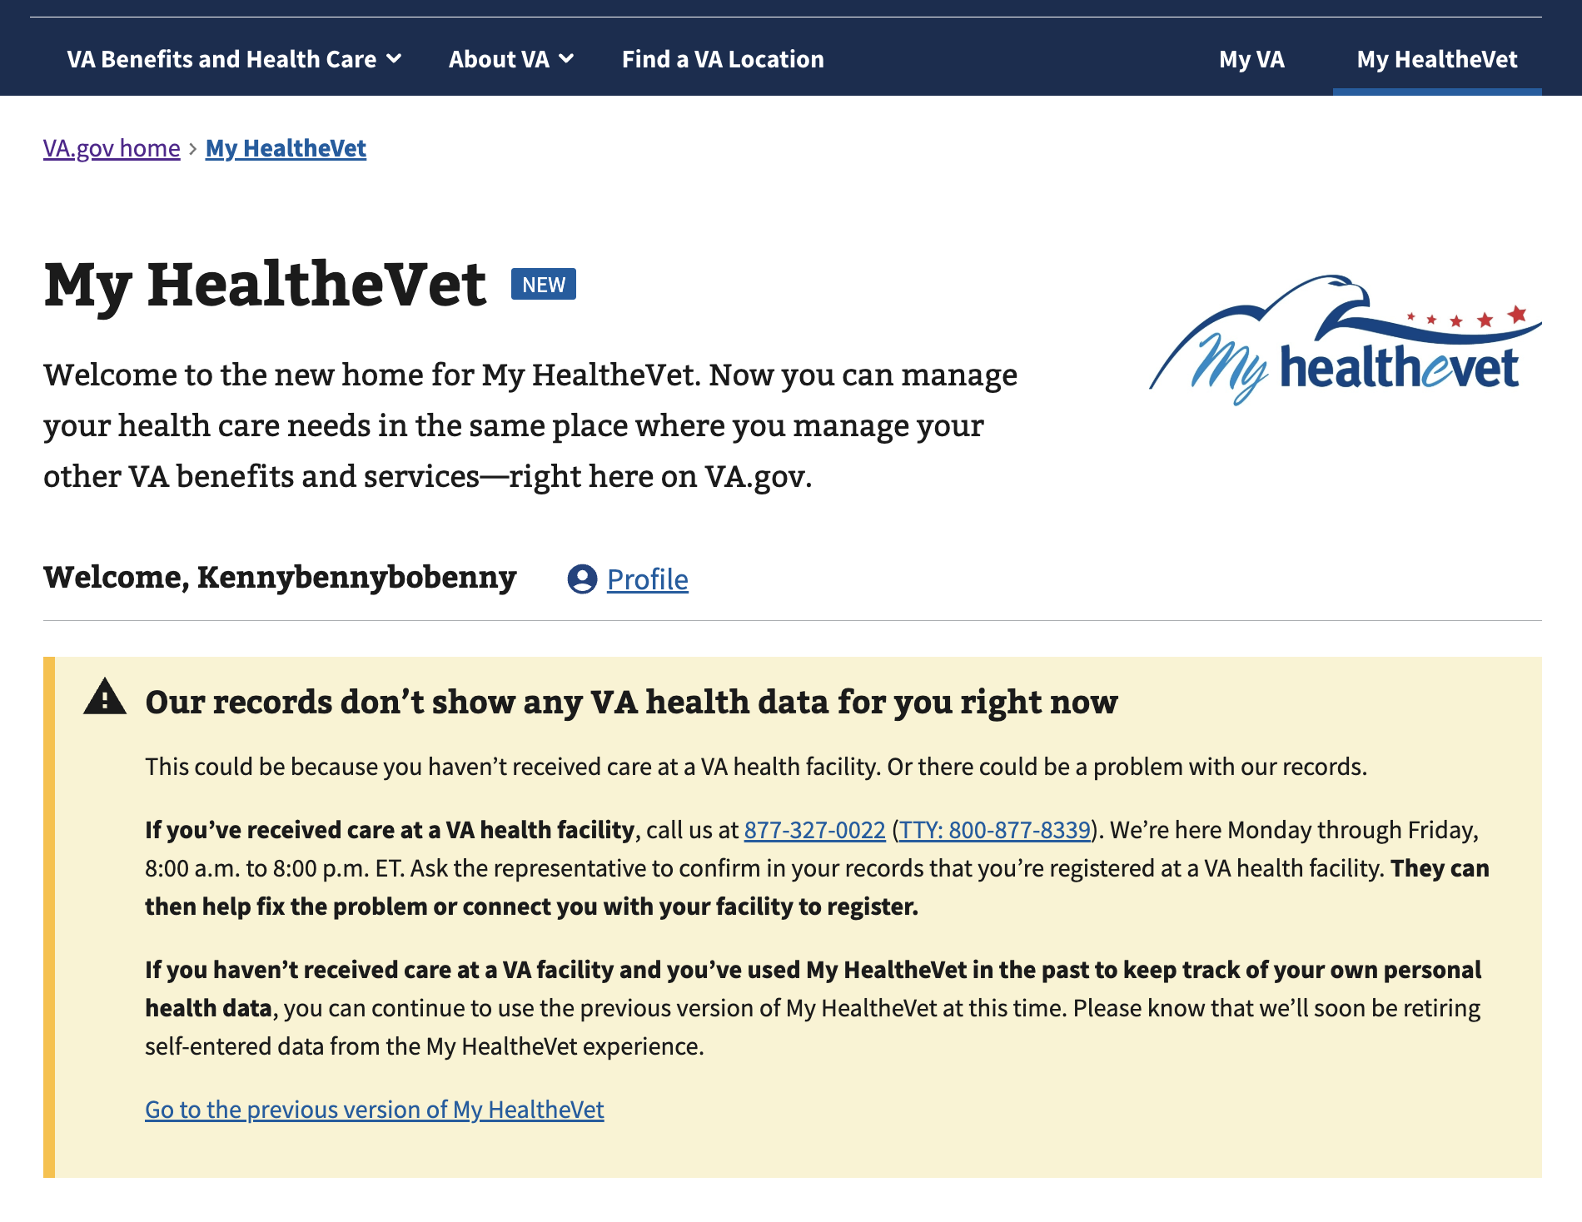

Figure 7. Landing Page with "No access to MHV" alert

#### If a user sees this yellow alert but believes it to be erroneous:

NOTE: In rare cases this alert may be erroneously displayed when a back-end system (e.g., MPI) has an incident and fails to provide data to VA.gov upon login. If a Veteran sees this incorrectly, check for system outages/incidents if possible, or tell them to try again in a few hours.

If the alert persists, the Veteran should call their local VA facility where they have received care.

### Alert case: MHV User Account problem / API error (new, Dec 2024)

During the sign-in process, VA.gov must match the user to a back-end record in My HealtheVet through a MHV UUID. This matching, which uses the MHV Account Creation API, may occasionally return an error. Some errors are transient, due to server glitches. Others require manual intervention. See the table lower in this section for error codes and triage approaches.

MHV account errors will need to be resolved before the user can proceed with using Secure Messaging, Medications, and Medical Records on VA.gov. Links for this functionality on the Landing Page will be altered to indicate that they are impacted by the error.

#### MHV Account Error displayed to user – Landing Page

This screenshot of an error alert is representative of all such alerts – they will vary only by the three-digit error code starting with “8”. The MHV Help Desk is the best option for Veterans to get these issues resolved, so that phone number is displayed within the alert. (See below for the possible error codes and their causes.)

Figure 8. MHV Account Error alerts include a code number that can be used to triage the cause of the issue

#### MHV Error codes

Most of the error codes require intervention by the MHV Help Desk. A few may be resolved by refreshing the page or signing out and in again.

|  |  |  |
| --- | --- | --- |
| **Error Code** | **Cause** | **Triage approach** |
| ***801*** | Multiple Active MHV Accounts found in MHV for user ICN and Deprecated ICN | MHV Help Desk: use the Profile Update button to resolve. If not resolved escalate HRC ticket to Tier 2. |
| ***802*** | ICN provided is not the Primary ICN | Could be caused in MHV back-end or other systems. Needs technical escalation. |
| ***803*** | For any other downstream MHV errors that stopped processing of the IAM Provisioning request in MHV | Veteran can try again later. Refreshing browser or signing out and in again should fix it unless there is a system outage. |
| ***804*** | User has a date of Death in MPI | MHV Account cannot be created if date of Death is accurate. |
| ***805*** | No active user account with ICN, but deactivated account found with ICN. | MHV help desk: reactivate their MHV account. |
| ***806*** | Multiple Accounts found with same Traits | MHV help desk: resolve manually. |
| ***807*** | User account found with Traits match, but MHV has a different ICN for that account | MHV help desk: resolve manually. |
| ***808*** | Invalid Token, Missing Token Value | User should try logging out and back in again. |
| ***809*** | A field passed to the MHV API is mis-formatted or missing | User should try logging out and back in again. |
| ***810*** | Upgrade to Premium Failed | Veteran can try again right away. |

## 3. Navigation and primary functionality

### How users can reach the My HealtheVet Portal and Landing Page

#### Starting from VA.gov

**Desktop users:** Those who sign in to VA.gov on a desktop computer will see a “My HealtheVet” link in the header, which will take them directly to the My HealtheVet-on-VA.gov landing page. This link is enabled for all signed-in desktop users, regardless of whether they receive VA health care benefits.

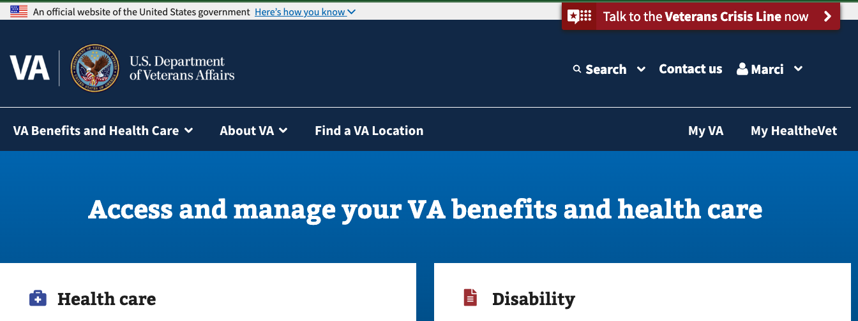

\Figure 9. Location of My HealtheVet link on desktop header

**Mobile users:** Those who sign in to VA.gov on a mobile device will need to click on the personal name dropdown menu at the top of the screen. There they will see the My HealtheVet link, which will take them directly to the My HealtheVet-on-VA.gov landing page. This link is enabled for all signed-in mobile users, regardless of whether they receive VA health care benefits.

Figure 10. Steps to find My HealtheVet link under the personal name menu on mobile

### My HealtheVet secondary navigation

The new My HealtheVet website contains a new secondary navigation feature at the top of the portal page and below the main VA.gov navigation menus. This set of tabs is persistent across all use cases within the portal on both desktop and mobile devices, allowing users to switch easily between tools. The navigation tabs link to the main page of each health tool within the integrated portal on VA.gov. The highlighted link signals what tool the user is on.



Figure 11. Desktop secondary navigation, with the "My HealtheVet" option highlighted because we're on the MHV Landing Page

Figure 12. Mobile version of secondary navigation, also highlighting the Landing Page

### Getting back to the previous version of My HealtheVet

Users can go back to the previous My HealtheVet website by **clicking the link in the second main paragraph on the landing page,** labeled “Go back to the previous version of My HealtheVet”:

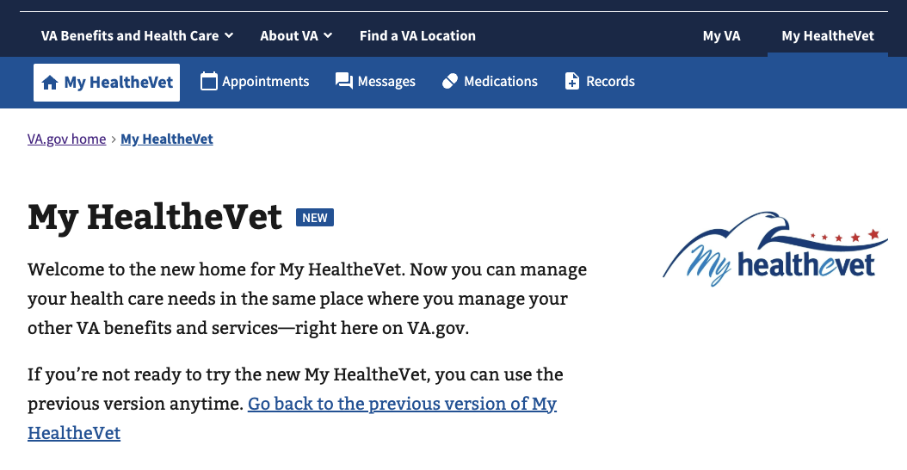

### Links within landing page

The links are generally self-explanatory, with the main features within each tool displayed as hyperlinks.

Note: The link in the “Medical records” box now directs the user to the new VA.gov version of that tool, as of mid-December 2024.

## 4. Common issues and error messages

Neither the My HealtheVet landing page nor the navigation bar relies on back-end services in order to display. Therefore, there are no common issues or error messages apart from the account-related topics covered in Section 2, User Access.